* **TRI-STATE 2025 Open/Masters Indoor Championships**
* **NY, NJ, CT**

Athletes will compete in an internationally certified state-of-the-art complex

**WHERE:**

Ocean Breeze Athletic Complex,

625 Father Capodanno Blvd. Staten Island , NY 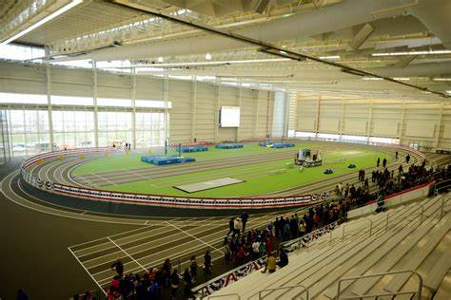

**WHEN:**

MARCH 1. 2025

10:00am – 3:00pm

Meet information:

* Link: <https://newyork.usatf.org>
* Fees – TBA Must be paid online
* Masters – 5 year age divisions starting at age 25 /Open – 14 and up
* Medals – top 3 in each event/age group

Stay active, keep competing and have fun!!!